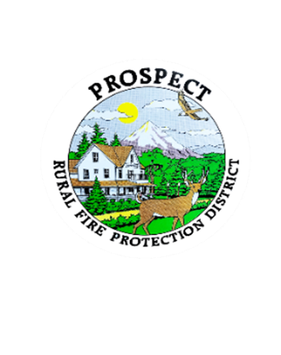

Agenda

Regular Board Meeting

September 15, 2025 at 7 pm

Prospect School - Media Center

**OUR MISSION** is to preserve and protect life and property in our Upper Rogue community.

1. Call to Order.
2. Roll Call.
3. Approval of Minutes.
4. Emergency additions to the Agenda.
5. Financial Report.
6. Chief’s Report.
7. Seismic Retrofit Report
8. Chiefs Evaluation; Goals from Chief and Board.
9. Discussion of working session to address policy book.

What sections or section to be addressed?

Amount of time to be spent or goal to be reached?

1. Public comment.
2. Adjourn.

Public comment, limited to 3 minutes per speaker

Next Board of Directors meeting, 7:00 pm, October 20, 18, 2025

BOD agenda Items due by 13 October , 2025