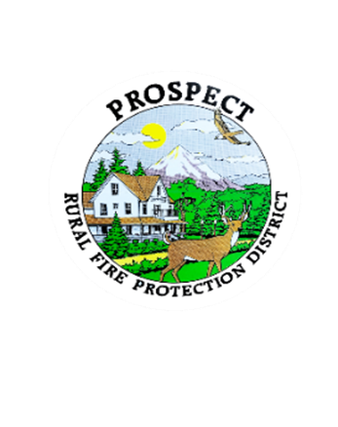

Agenda

Board Special Work Session

September 21, 2025 at 0100 pm

Crater Lake RV Park

46611 Hwy 62, Prospect

**OUR MISSION** is to preserve and protect life and property in our Upper Rogue community.

1. Call to Order.
2. Roll Call.
3. Develop plan going forward to resolve the policy book.
4. Public comment.
5. Adjourn.

Public comment, limited to 3 minutes per speaker