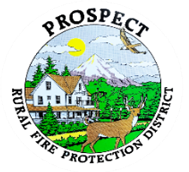

Agenda
Regular Board Meeting
December 15, 2025 at 7 pm
Prospect School – Main Parking lot

OUR MISSION is to preserve and protect life and property in our Upper Rogue community.

- Call to Order.
- Roll Call.
- Review of Minutes.
- Emergency additions to the agenda.
- Financial Report. Review only.
- Chief’s Report. Questions by exception.
- Litigation lodged against department over copyright infringement. Update.
- For good of the order. Round the group. Only issues that would require immediate attention.
- Public comment.
- Adjourn.

Public comment, limited to 3 minutes per speaker

Next Board of Directors meeting, 7:00 pm, January 19, 2025
BOD agenda Items due by 12 January, 2025

