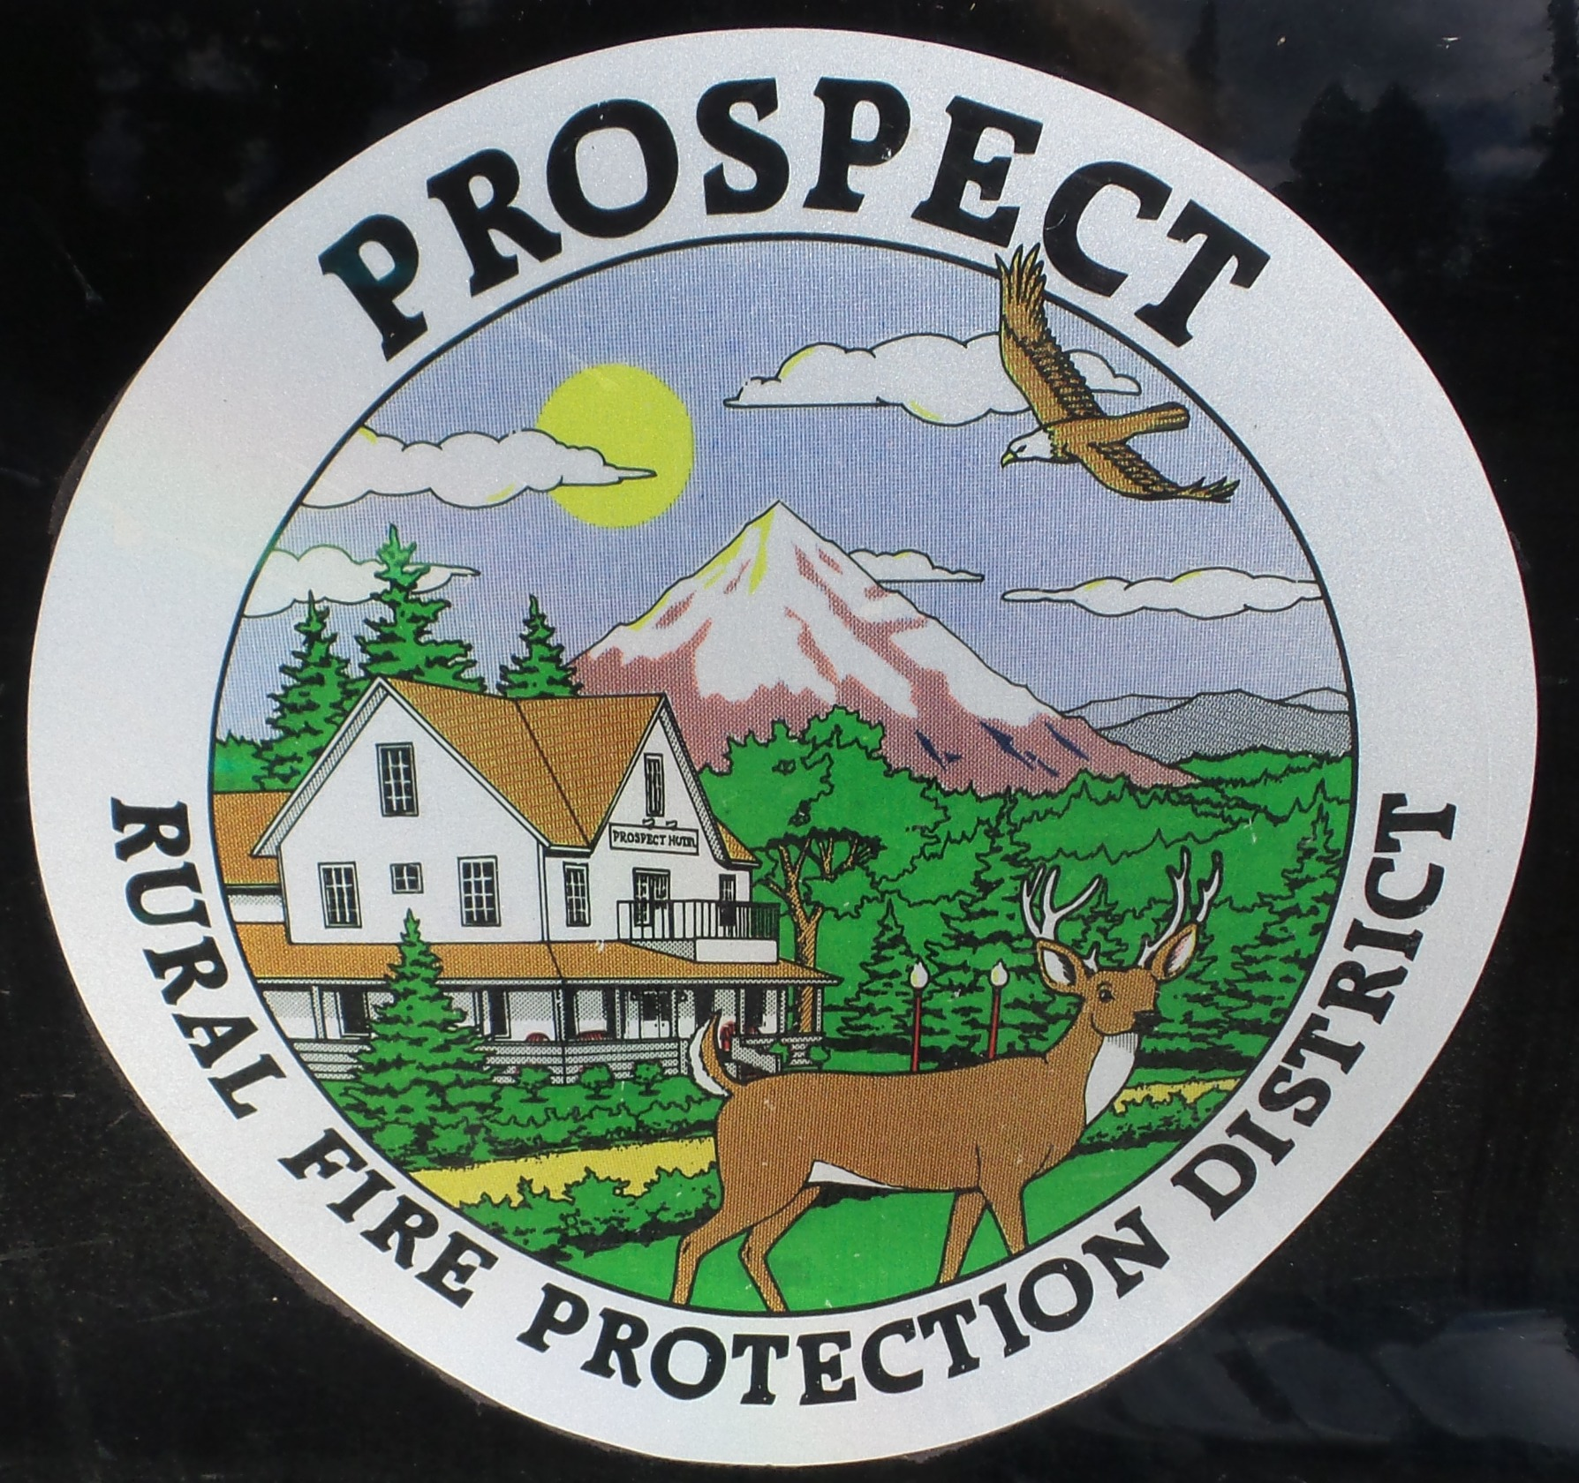
Prospect Rural Fire Protection District
Minutes of the Board of Directors
Regular Meeting, 7:00 pm
October 20, 2025

President Mike Pearson called the meeting to order at 7:00 pm.

Attending: Mike Pearson, Pam Lee, Gunner Gibson, Natalie Williams, Joyce Dierking
Also Attending: Fire Chief Lyle Neville, Bob Jones (financial officer) and 6 other community members

Approval of September minutes. Natalie made a motion to accept, Pam seconded. Mike voted yes, Pam voted yes, Gunner voted yes, Natalie voted yes, Joyce voted yes. Motion passed.

Bob Jones gave his financial report. Then he presented a resolution approving an Audit Engagement Letter for two different services with BWB& Company (auditing company). Pam made a motion to accept this resolution, seconded by Natalie. Mike voted yes, Pam voted yes, Gunner voted yes, Natalie voted yes, Joyce voted yes. Motion passed and documents were signed by Bob and Lyle, attested by Joyce.

Lyle gave his monthly Chief's report. Kristi Gibson gave us a final seismic project report. The retro fit for station one is completed. Chris King reported that the old water tender is workeable and should be able to pump water when repairs are complete by January. Natalie read Kathleen Conner's grant report.

Mike suggested that the board consider approval to fund SDAO training for Kristi Gibson for seeking grants for the new fire station on First Street on the property donated by the Burrell family, Joyce made a motion to do this, seconded by Pam. Mike voted yes, Pam voted yes, Gunner voted yes, Natalie voted yes, Joyce voted yes. Motion passed.

The new policy book format was presented. Additions and corrections were discussed. A motion was made by Natalie to adopt the new format for the Prospect RPFD Policy book, seconded by Gunner. Mike voted yes, Pam voted yes, Gunner voted yes, Natalie voted yes, Joyce voted yes. Motion passed. At the work session on October 26, which will be held at the Crater Lake RV Club house at 1:00 pm, more work will be done on the policy book.

The meeting was opened for public comment. Concerns expressed: 1) getting certified mechanic for checking brakes, clutch, etc. on vehicles 2) getting volunteer training in search and rescue (ie roping down rocks) in emergency situations.

Joyce made a motion to adjourn, seconded by Pam. Mike voted yes, Pam voted yes, Gunner voted yes, Natalie voted yes, Joyce voted yes. Meeting adjourned at 8:13.

Next Board of Directors meeting, November 17, 2025
BOD agenda items due by October 31, 2025.

Minutes and a recording of this meeting available at www.prospectrfpd.org

