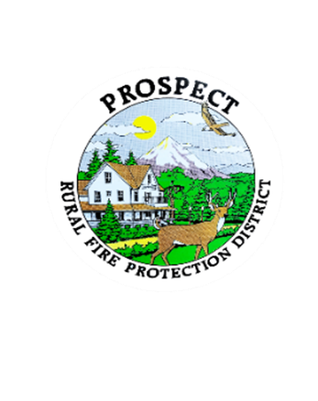

Agenda

Regular Board Meeting

October 20, 2025 at 7 pm

Prospect School - Media Center

**OUR MISSION** is to preserve and protect life and property in our Upper Rogue community.

1. Call to Order.
2. Roll Call.
3. Approval of Minutes.
4. Emergency additions to the agenda.
5. Financial Report. Consideration of a resolution approving Audit Engagement Letter with BWB&Co..
6. Chief’s Report. Requested update on tanker repair.
7. Seismic Retrofit Report.
8. Future projects preparation discussion.
9. Discussion of new policy book format. Potential decision to adopt. Assignment of policies to individuals and working groups
10. Discussion of working session to address policy book, 26 Oct 2025.

Further assignment of policies to individuals and working groups.

Review and edit products to be presented for adoption.

1. Public comment.
2. Adjourn.

Public comment, limited to 3 minutes per speaker

Next Board of Directors meeting, 7:00 pm, November 17, 2025

BOD agenda Items due by 7 October , 2025